QUALITY ASSESSMENT PLAN – EVALUATION for 2013/2014 School Year
The sequencing of the various assessment processes were given in Figure 4. Following is a discussion of results of the most current assessment cycle.
- Student course and instructor evaluation by students
IDEA—Course and instruction evaluations were done by students for all courses taught during the 2013/2014 academic years. The details of these results are confidential in nature, but the summary results are shown on the outcome assessment follow-up forms that are provided to the applicable instructors. Based upon a review by the Department Chair, a decision was made to replace several adjunct professors with permanent faculty in the 100 and 200 level courses. It was felt that these courses provide a source for recruiting new students and therefore an instructor that is part of the faculty may enhance the student’s educational experience by relating more of their research and future potential to the students.

- ASC Region 6 competition
The University of New Mexico has participated in this regional Associated Schools of Construction competition in Reno, Nevada since 1998. The number of teams sent to the completion has varied from one to five with categories representing topics such as Heavy Civil, Commercial, Design Build, Mixed Use, and Sustainable Building. In 2014, the UNM CM program sent three teams to compete in the categories of Commercial, Design-Build, and Sustainable Building. One of the indicators of the success of the program is that each of the teams had students from the UNM Architecture Department participate in the competition. In 2014, one individual received a second place award for Alternates competition. The judge’s reports indicated that all of the teams scored in the top half of their categories. Special mention was provided on the group cohesiveness and accuracy in estimating. There is no specific form for recording the results of the CM competition. However, the results are determined by a panel of judges and made available to the faculty advisor/coach for the team. An action item was identified to develop a database of the findings and work to define a matrix for better tracking the performance historically.

- Capstone course performance
The evaluations of the capstone course, CE 497L Senior Design, have been positive (see exhibit 2). Students improved in several areas including confidence, technical knowledge, and managerial skills. They enjoy the reality of the experience. The feedback reinforces several of the tenets of the UNM Philosophy of Education of the Construction Management. For the 2013/2014 period, 14 CM students were evaluated as members on 10 various teams. The results from the faculty and mentor surveys indicated that all of the students achieved a score of 2 or better on the rubric scale to indicate satisfactory demonstration of the required topics.

- Graduate and Alumni Data
By using the data available from the Linkedin social media website for UNM Construction Management Alumni, the Undergraduate Coordinator was able to categorize the employment of all of the recent graduates of the program. Additional information regarding the type of employment and graduate school attendance was also tracked. The information was added to the existing database of recent graduates and the following chart was developed to demonstrate the employment statistics of graduating seniors. Action plans include sending a survey to all alumni group members requesting more specific information at the end of the spring 2015 semester.

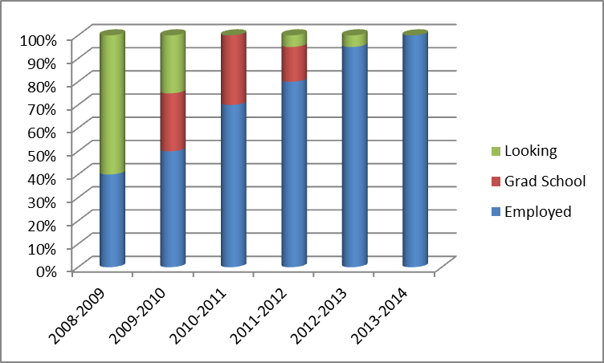

- Employer survey
Employer Survey—The 2014 survey was sent via email to the AGC and ABC for distribution to their members. Results were obtained from 12 companies. The results of the survey are demonstrated in the attached chart. The survey results were quite positive with the average of none of the categories being below a 3.0. However, it was noted that in several areas the UNM expectations were lower than the industry needs. Thus an action item was developed to focus on the largest differential – in the field of technical competence. The Undergraduate Committee will work with the faculty to determine the cause of this discrepancy and prepare plans to improve the results.
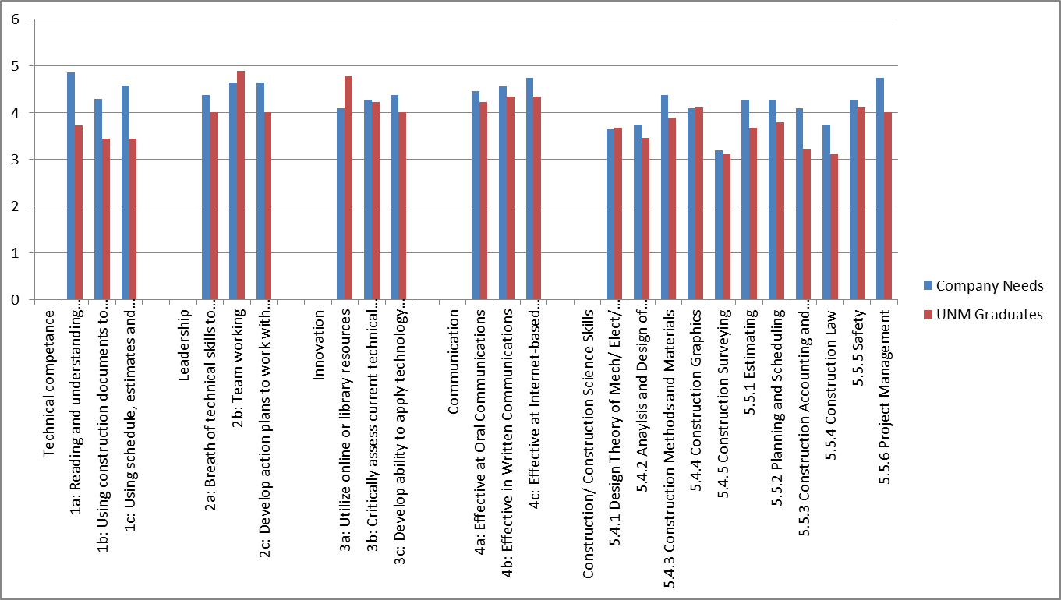

- Curriculum review
The Outcome Assessment Reports from all of the courses were entered into the University’s TK20 program for tracking Student Learning Outcomes. The final report from the evaluation is available at the program website: http://civil.unm.edu. Of the 31 outcomes measured, 21 met the established criteria, 3 partially met the criteria, and 5 did not meet the established criteria. Action plans have been developed for the 9 areas in which the criteria were not fully met. The instructors are responsible for implementing their appropriate action items and reporting the results by the review of the 2014/2015 outcomes in October 2015 to the Undergraduate Committee. The following chart depicts the results of the TK20 program in a graphical format. The horizontal red line indicates the goal of 75% of the students being evaluated as satisfying the criteria. As many courses feed into the topical content, the chart is plotted based on the lowest score for the respective area.

- Student Counseling Sessions
The Construction Management advisers met to discuss the information gained from the counseling sessions with the students. The below chart was developed based on the information provided by the students regarding the starting salaries they were offered upon graduation. The predominant feeling was that the course work was acceptable and the program was moving in the right direction. An action item was developed to develop a survey form and check list to be used during the interview process that will be implemented in the 2014/2015 counseling sessions.

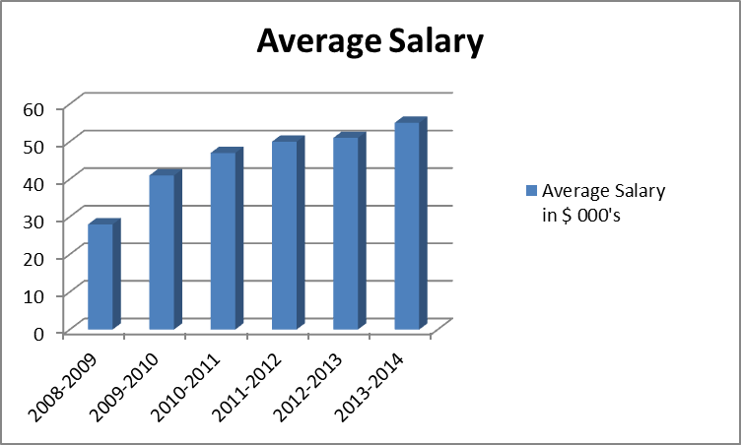

- ACCE Review
The last American Council of Construction Education ACCE accreditation review was conducted from 11 – 13 September, 2011. The ACCE board voted for a three-year accreditation with a Special Report addressing Section VIII of the Standards, Relations with the General Public. The final report is available through the Undergraduate Coordinator. The report identified 7 strengths, 8 weaknesses, 5 concerns, and 6 undeveloped potentials. The following chart demonstrates the trends of these results relative to previous accreditation visits:

Summary of Assessment Tools:
Based on the results of the above assessment tools, the Undergraduate Committee assessed the impact on the overall program. The summary of items indicated the areas where more attention was needed and corrective actions need to be implemented. The following chart illustrates the results of that analysis.
 | Student course and instructor evaluation | ASC Region 6 competition | Capstone course performance | Graduate and Alumni Data | Employer survey | Curriculum review | Student Counseling Sessions | ACCE Review
Program Goals
1. Technical Competence | Low | Low | Low | Low | High | High | Low | High
2. Leadership | Low | Low | Low | Low | Low | High | N/A | Med
3.Innovation | Low | Low | Low | Low | Low | Low | N/A | Low
4.Communication | Low | Low | Low | Low | Med | Low | N/A | High
5. Faculty | Low | N/A | N/A | N/A | N/A | N/A | N/A | Low
* The above chart reflects the level of concern for the goal as indicated by the assessment tool.
A low rating indicates that the assessment tool does not find fault in the area and thus the level of concern is low. A Med rating indicates that the assessment tool identified some minor concerns for the respective goal. A high rating indicates an area where corrective actions are necessary to address the high level of concern.
The Undergraduate committee evaluated each of the program goals with a perspective on the information provided by the various assessment tools.
Goal 1: Technical competence – it was identified by the Employer Survey that the skills of the recent graduates was significantly lower than the skills need by the industry representatives. Additionally, the curriculum reviews by the instructors felt that the results of the students were lower than what was expected in 2 of the courses where technical competence was evaluated (CE 171 and CE 376). Finally the ACCE visit from 2011 identified several weaknesses regarding the curriculum. All other assessment tools did not identify any significant deficiencies in this goal.
Goal 2: Leadership - The curriculum review identified that for 1 course (CE 279) the scores were lower than what was expected. Additionally, the ACCE review identified a concern in the Relations with Industry category. All other assessment tools did not identify any significant deficiencies in this goal.
Goal 3: Innovation – No significant findings were found from any of the assessment tools and thus there is a lower level of concern for this program goal.
Goal 4: Communication – The employer survey indicated slightly lower values for the communication skills of the program graduates relative to what they expected from new hires. Additionally the ACCE accreditation visit found a weakness with the program regarding what information is being made available to the public. All other assessment tools did not identify any significant deficiencies in this goal.
Goal 5: Faculty – No significant findings were found from any of the assessment tools and thus there is a lower level of concern for this program goal.

Assessment Plan Action Items
The following list is a compilation of action items, along with their status, that were generated as a result of Undergraduate Committee meetings, faculty reviews, Industry inputs, and the results of the assessment process:
2013/2014 Action Items:
Based on the summary of our assessment results we’ve identified potential areas of improvement related to the following goals:
Goal 1: Technical Competence
Action 1: Instructors for CE 171 and CE 376 will review the teaching methods to determine better methods to portray the course information and improve student knowledge retention.
- This is an ongoing process that will be evaluated at the end of each semester to determine any trends for improvement.
Action 2: Based on the improvement of teaching methods in Action 1, it is anticipated the skills of the students will increase and likewise the opinion of the employers will improve.
- Working with the AGC, field trips to active construction sites are organized on a monthly basis to improve the students understanding of the construction process.
Action 3: The ACCE weaknesses are associated with the implementation of the course review process. The CM program will require assessment forms to be completed by all applicable CM course instructors and the data entered into the University Wide TK20 database.
- As evidenced by the TK20 report, the program has been established and a review cycle is implemented.

Information gather ed form our empolyers and CAC identify that we need additional communication skills.
Goal 2: Leadership
Action 4: The instructors for CE 279 will review the teaching methods to determine better methods to portray the course information and improve student knowledge retention. Discussions with industry professionals has recommended more site visits and guest lectures from industry could be effective in improving student performance.
- This is an ongoing process that will be evaluated at the end of each semester to determine any trends for improvement.
- The AGC Construction Leadership Council has agreed to assist in providing guest lecturers and field trip opportunities for the students.
Action 5: The weakness with the relations with Industry as identified by the 2011 ACCE review deals with the minimal communication with program alumni. Since that time, a Linkedin group has been developed for alumni that has successfully attracted over 20 alumni. Additionally, all graduating seniors from the program are now required to establish a Linkedin account and join the UNM Construction Management Alumni group.
- The Linkedin site provide valuable alumni information that is being collected to assist in assessing the effectiveness of the program and keep the alumni appraised of the changes and initiatives within the school.

Goal 4: Communication
Action 6: The employer survey along with comments from the Construction Advisory Council have identified an importance for teaching oral and written communication skills to the students. The Department Chair has established a requirement that all faculty will increase the amount of writing and presentation assignments in their classes. The School of Engineering has developed a program to work with the English Department to develop courses specifically related to engineering and construction writing skills.
- Training has been provided to the instructors to require more papers and presentations.
- The English department has provided their course syllabus to acquaint the faculty with the skills the students should possess.
- The department is looking into bringing in additional help for instructors to grade papers on grammar.
- The Undergraduate Committee has requested that more data be generated from the Student Advising sessions.
Action 7: The 2011 ACCE accreditation visit identified a weakness with the information that was being available to the public. The AGC Endowed Chair has been tasked with keeping the information up to date and accurate.
a. The site is updated by the middle of each semester with the applicable information from previous review cycles.

Other Action Items
Action 8: The Industry Advisers and Faculty approved the decision to reduce the number of credit hours from 130 to 123 to improve course offering efficiency.
- Based on the recommendations of the Undergraduate Committee, the faculty and industry approved the course reductions.
- The Undergraduate coordinator will prepare the forms and submit the application to the Faculty Senate for curriculum changes.
Action 9: The CAC has requested that a survey be conducted to determine the effectiveness of various contributions on the recruitment of students.
- An initial iClicker survey was conducted in the CE 477 class
- Additional surveys are being prepared by the Undergrad Committee to be administered as part of the student advising sessions.
Action 10: The Undergraduate Committee has requested that more data be generated from the Student Advising sessions.
- The Undergraduate Coordinator is developing the survey and training for the academic advisers to be started in the Fall 2014 advisement sessions.

